**Course ___Methods_Test 2_ Year __12_______**

Student name: ________________ Teacher name: ________________

Date: 30 March

**Task type: Response**

**Time allowed for this task: _____45______ mins**

**Number of questions: _____8______**

**Materials required:** Calculator with CAS capability (to be provided by the student)

Standard items: Pens (blue/black preferred), pencils (including coloured), sharpener, correction fluid/tape, eraser, ruler, highlighters

Special items: Drawing instruments, templates, notes on one unfolded sheet of   
A4 paper, and up to three calculators approved for use in the WACE examinations

**Marks available: __46____ marks**

**Task weighting: __10__%**

**Formula sheet provided: Yes**

**Note: All part questions worth more than 2 marks require working to obtain full marks.**

Q1 (3.2.1-3.2.3) (3 & 3 = 6 marks)

Determine  in terms of  for the following.

1.  given that  when .
2.  given that  when .

Q2 (3.2.21-3.2.22) (4 marks)

A particle travels along a straight line such that its acceleration at time  seconds is equal to . When the displacement is 22 metres and when the displacement is -10 metres. Determine the displacement when .

Q3 (3.2.10-3.2.11) (2. 2, 1 & 2 = 7 marks)

Consider the function  which is graphed for .

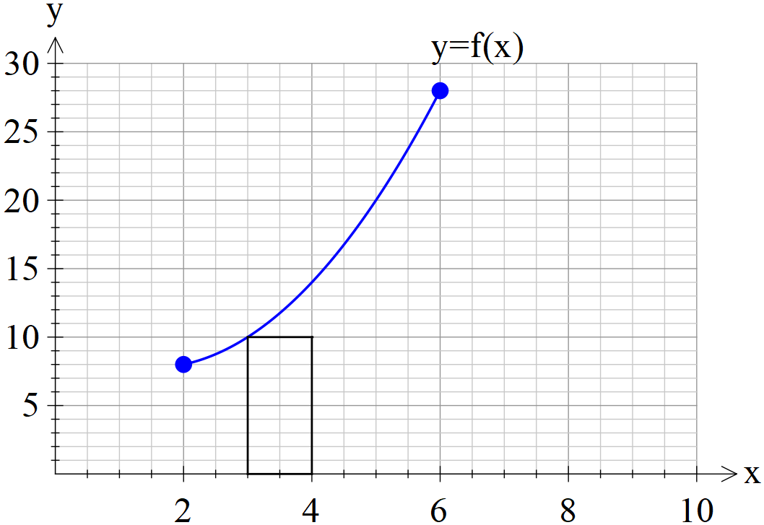

1. By using rectangles of width one unit, as shown above, determine a lower estimate for the area under  for .
2. By using rectangles of width one unit, as shown above, determine an upper estimate for the area under  for .
3. Determine a better approximation for the area under  for .
4. Describe two different methods to improve the approximation for the area under  for .

Q4 (3.2.18-3.2.17) (3 & 2 = 5 marks)

An oil tank is drained of oil such that if  of oil in the tank  seconds after draining commences is described by .

The initially full tank is emptied in 2 mins.

1. How much oil was in the full tank? (nearest kL)
2. How much oil was drained from the tank in the fifth second, nearest kL.

Q5 (3.2.11-3.2.14) (2, 2 & 2 = 6 marks)

Consider a function  which is only defined for  with



It is known that  for  and  for .

Determine.

1. 
2. 
3. The area between  and the x axes for .

Q6 (3.2.20) (4 marks)

Determine to two decimal places the area between the curves  and .

(Hint- Sketch the curves first on your classpad)

Q7 (3.2.16) (2 & 2 = 4 marks)

Consider 

Determine.

1. 
2. 

Q8 (3.1.4) (4 marks)

The instantaneous rate of decline in the number of kangaroos on a particular park is 30% of the population per year. If there were 12 050 kangaroos on the park 3 years ago, how many will be on the park in four years from now

Q9 (3.2.6) (2 & 4 =6 marks)

1. Determine .
2. Using your result from part (a) and **without using your classpad** determine .

**Working out space**

**Working out space**